Optimal Placement of Mobile Health Clinics in Medically Underserved Parts of the United States

15.C57 Optimization Methods
December 7th, 2025
Ryan Gibson, David Izrailov, Vardhan Koripally

Problem
We aim to tackle the issue regarding medically underserved communities' lack of access to healthcare facilities, primarily in less wealthy, rural counties within the United States. The current band-aid solution in the US is mobile health clinics, which act as a mini-hospital on wheels, moving to certain locations to serve these communities. Our goal is to develop a model which will optimally place these mobile clinics within a county's borders, such that we cover the most amount of people within a given commute time subject to a limited number of mobile health clinics. We also wish to minimize the maximum time required for any individual to receive urgent treatment. To keep the scope of the problem limited, we focus only on Bee County in rural Texas. This is home to the main town of Beeville with some smaller towns scattered throughout. Bee County was chosen as the primary candidate for this project due to its ranking as the most medically underserved county in rural Texas (HRSA, 2025). A map of Bee County for reference is shown below (Texas Almanac, 2021):
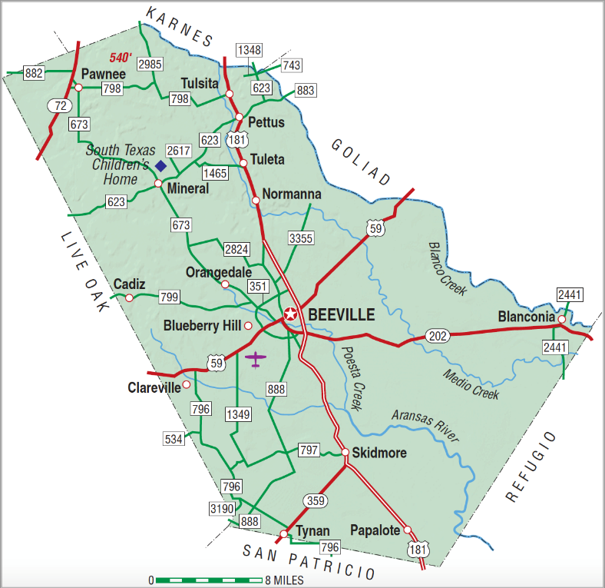

Importance
Due to recent budget cuts to several healthcare facilities from the federal government, rural populations will be increasingly vulnerable to losing access to healthcare. Mobile health clinics may need to become more prevalent in the upcoming future as hospitals begin to close as a result of new legislation. As a result, models which can optimally place these mobile health clinics could prove to be useful as this problem becomes much more relevant in today’s political landscape. It is important that all individuals, regardless of socioeconomic status, have access to health services, which is a large motivation for us to focus on this topic.

Data
The first component of data which we needed to get was population data within various towns within Bee County. We got this information from the National Historical Geographic Information System (NHGIS, 2025). This organization hosts an online repository for census data from the most recent census in 2020 all the way back to 1790. However, this data only breaks up the data into census tracts, large areas of land that cover a large amount of people within the county. Because of that, the vast majority of this information was collected by hand through looking up each town’s name and finding their census information. This information varied as some towns had 2020 census data, and others had 2000 census data. Overall, Bee County has around 30,000 people according to the NHGIS data. Unfortunately, our method only accounted for 16,000 people as many live outside these towns in isolated homes. However, we believe our methodology is sufficient to accurately represent most of the residents’ location information. We can reasonably assume that the uncounted population is evenly distributed across the county and, therefore, the relative coverage outcomes of any proposed clinic location would remain proportionally the same, since no particular area is disproportionately affected by the uncounted population. However, we still need to capture the edges of the county to better understand the maximum travel time a person may take given a selected clinic location. This was also captured in our demand dataset as a population of 1 in the extreme corners of Bee County. With this, we had a total of 23 demand sites, marked by their population and coordinates (latitude and longitude).
In addition to population data which served as demand, we also manually defined candidate locations. We looked at the entire county and found places with the following criteria:
- Road access - Easily connected or on a major non-dirt road
- Parking availability - Ensures the mobile health clinic can feasibly exist there
This led to parking lots, parks, post offices, and churches being most of the candidate locations, adding to a total of 14 locations. While this methodology is not the most rigorous, we believe this judgement is necessary to ensure a mobile health clinic is useful and accessible. In addition, we noted any existing healthcare facility to ensure that we don’t place a mobile health clinic right next to a hospital, which prevents double coverage. Similar to the demand sites, we also recorded the coordinates of each potential clinic site.
The final critical piece of information required was the road network itself. We used a Python package called OSMNX, which returns a graph object of road networks within a predefined area. This allowed us to build our network edges and nodes with the distance and speed limits playing into the “cost” of each arc. An image of the road network is shown here:
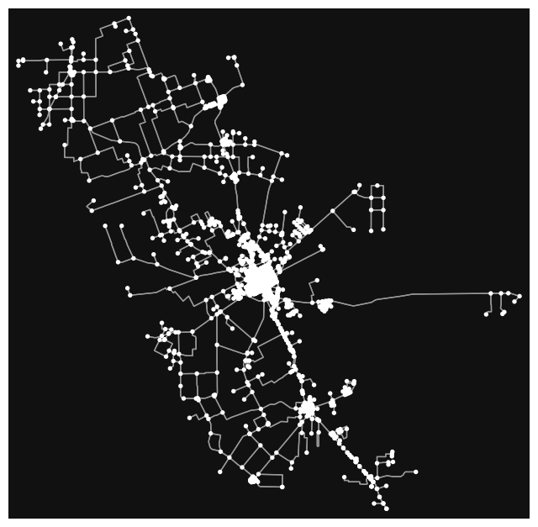
Now that we have identified the demand nodes, the potential clinic locations, and the road network, we almost have all the necessary information to run our optimization model. The last piece of information we need to get are the travel times between each demand node and each clinic location. Using OSMNX, we found this by utilizing Dijkstra’s algorithm to solve for the shortest path between each pair or demand and clinic nodes. It’s important to note that this method found the shortest path utilizing travel time as opposed to distance. This is important because our objectives rely on the travel times as opposed to total distance. By utilizing the speed limits of each road within the network, we were able to come up with these travel times that we could then put into our optimization problem.

Approach
The approach was to use both a maximal coverage optimization for the primary objective, and an optimization problem to minimize the maximum time an individual would have to travel to reach a healthcare facility for the secondary objective. By solving both problems, we can understand the tradeoffs between coverage and maximum travel distance in Bee County. Both model formulations can be seen below:

Maximum Coverage Location Problem
Sets:
$I=$ set of demand points
$J=$ set of candidate clinic locations
$N_{i}⊆J=$ set of clinics that can reach demand i within threshold T
Parameters:
$p_{i}=$ population at demand point i
$K=$ maximum number of facilities that may be opened
$T=$ coverage threshold
Decision Variables:
$x_{j}=$ 1 if facility j is opened, otherwise 0
$z_{i}=$ 1 if demand point i is covered, otherwise 0
Optimization Model:
$\max{Σ_{\left\{i∈I\right\}}p_{i}⋅ z_{i}}$ (Maximize Covered Population)
s.t. $z_{i}≤ Σ_{\left\{j∈N_{i}\right\}}x_{j} , ∀i ∈ I$ (Coverage Constraint)
$Σ_{\left\{j∈J\right\}}x_{j}≤ K$ (Clinic Budget Constraint)
$x_{j}∈ \left\{0,1\right\},∀j ∈ J$ (Binary Constraint)
$z_{i}∈ \left\{0,1\right\}, ∀i ∈ I$ (Binary Constraint)

Minimizing the Maximum Travel Time Problem
Sets:
$I=$ set of demand points
$J=$ set of candidate clinic locations
Parameters:
$t_{ij}=$ travel time between demand i and clinic j
$K=$ maximum number of facilities that may be opened
Decision Variables:
$x_{j}=$ 1 if facility j is opened, otherwise 0
$y_{ij}=$ 1 if demand point i is covered by facility j, otherwise 0
$R=$ maximum travel time
Optimization Model:
$\min{R}$ (Minimize the Maximum Travel Time)
s.t. $Σ_{\left\{j∈J\right\}}y_{ij}= 1, ∀i ∈ I$ (Assignment Constraint)
$y_{ij}≤ x_{j}, ∀i ∈ I, j ∈ J$ (Open Clinic Constraint)
$Σ_{\left\{j∈J\right\}}x_{j}≤ K$ (Clinic Budget Constraint)
$R ≥ t_{ij}⋅ y_{ij}, ∀i ∈ I, j ∈ J$ (Maximum Travel Time Constraint)
$x_{j}∈ \left\{0,1\right\},∀j ∈ J$ (Binary Constraint)
$y_{ij}∈ \left\{0,1\right\}, ∀i ∈ I, j ∈ J$ (Binary Constraint)
These original problems, however, do not consider any existing hospitals located within Bee County. There is one hospital located in Bee County and so our team reran our models with slight alterations to the optimization formulations to account for this hospital in Beeville, determining the same optimal clinic locations now including the hospitals coverage as well.
It’s important to note that all four models are important to analyze because of the recent federal budget cuts discussed in the Importance section. We need to understand how our solution will change in case the hospital in Bee County is permanently closed. This would allow us to quickly pivot ourselves to a new solution if needed during obviously trying times for the healthcare system within the county.
Software-wise, the road network and travel times were found using OSMNX as shown in the previous section. Additionally, we used other Python packages such as NumPy, Pandas, and GurobiPy, to facilitate data handling, and running the optimal model itself. We chose to use Python as OSMNX is a well-documented and easy to use Python package, and Julia does not have as easy of an approach to getting this network information. Looking back, the biggest challenge with our approach was mostly collecting the demand and potential clinic location data manually, as it was rather time-consuming.
While our approach is limited to Bee County, the problem is easily scalable or applicable to other counties or to include multiple counties at once. The only challenge is that it requires collecting population data and candidate locations for the region chosen.
Results
When we ran our maximal coverage model, we set our parameters to be K = 1 (we can place 1 mobile clinic), T = 15 (a demand node must be within a 15-minute drive to count as being covered), and the travel times were computed using the OSMNX package. The result of the non-hospital model is that we would place the mobile clinic in a Walmart parking lot in Beeville. This result makes sense because it is centrally located within the county and is close to a major highway that connects most of the county’s population. The result of the hospital model is that we would place the mobile clinic in a church parking lot in Mineral. Notice that this result is different from the previous model because the hospital that’s currently located in Beeville would cover the central and south section of the county while the clinic in Mineral would help to serve the north part of the county that has less high-speed roads. It wouldn’t make sense to place a mobile clinic in Beeville if a hospital was already located there.
When we ran our minmax model, we found that if there was not a hospital, we would place our mobile clinic near a post office in Normanna, and the maximum travel time is 33.09 minutes from Blanconia. When we take the existing hospital into account, we would place our mobile health clinic in Mineral with the maximum travel time being 24.66 minutes also from Blanconia. These results make sense because the existence of a second healthcare facility would obviously decrease the maximum travel time faced by the population. This also marks a significant decrease in the current solution where it now takes approximately 35 minutes for a person on the northwest edge of the county to get to the hospital that’s currently in Beeville.
Given these results, we would recommend placing the clinic in Mineral as it helps to cover the most people as well as decreases the maximum travel time the best. If the hospital in Beeville was to close, we would need to move our facility to Beeville to cover as many people as possible. We would choose this location instead of the one in Normanna because Beeville is by far the highest populated population center within the county and, from our perspective, having local access in a population hub would be more important than minimizing the maximum distance traveled for a person living in an unincorporated place. However, these decisions should be discussed in more depth depending on factors we can’t account for in our optimization model.
We are quite happy with these results as they accurately incorporate human decision making with optimization, resulting in a logical, yet optimal, decision of which candidate facilities to choose from.

Discussion
As shown by our models, we can see that the placement of even a single mobile healthcare clinic can improve both coverage and the maximum travel time a resident of Bee County would have to take to get to a healthcare facility. However, during our analysis we found that Bee County is already well covered in terms of geographic coverage, with their current hospital located in Beeville, the central most city within the county. Because of this, we questioned how this could be the case, as the HRSA listed Bee County as the most medically underserved rural county in Texas. As we dug deeper, we found that this is actually due to the county’s lack of primary care physicians (PCPs) within the county (Texas Community Health News, 2023). Compared to the Texas average of 77.6 PCPs per 100k residents, Bee County only has 34.1 PCPs per 100k residents. This means that, for the entire population of Bee County, there are only 11 PCPs that serve the entire population. Even though this is the true reason behind Bee County is medically underserved, our solution will still help this community. The presence of a mobile health clinic means that there are more PCPs serving the region, serving this community better than if the hospital was the only source of healthcare. In addition, we would still increase geographic access to healthcare by reducing the maximum travel time a resident would have to take by 29.5%, leading to higher convenience for those living in the most rural areas of the county.

Further work
If we had more time, the first thing we would do is increase scope, moving from one county to a collection of counties. Perhaps incorporating a few neighboring counties to optimally serve a larger region of rural Texas. In addition, given that these clinics are mobile, modelling several periods where we can move from a set of optimal placements given some conditions, to another set. For example, in the summer, hunting injuries would be more prevalent so placing these clinics near common hunting grounds may be beneficial. This would add to the complexity of the problem while utilizing the mobile nature of these facilities. Lastly, we would explore a method to automatically collect population data and candidate locations to make the approach even more scalable in practice. This would also allow us to get rid of our assumption of an evenly distributed unaccounted for population as discussed in the Data section of our report.

Conclusion
In summary, we collected data about Bee County, TX in the hopes of increasing access to healthcare in Texas’s most medically underserved county. Through optimization, we achieved the optimal placements of mobile health clinics which would both increase coverage and reduce the time taken to reach a healthcare facility from 35 minutes to 25 minutes at maximum. We achieved this through the use of OSMNX, Gurobi, Python, and optimization methods we learned in class. The approach was designed to be scalable in theory if needed and would become much easier if spatial population data and candidate locations were more readily available. Overall, we are happy with the work we have done and believe our results could prove to be useful in the current state of the unpredictable political landscape in the United States.

Citations
HRSA, Find MUA/P (2025). HRSA. Retrieved 2025, from https://data.hrsa.gov/topics/health-workforce/shortage-areas/mua-find.
NHGIS. (2025). National Historical GIS. NHGIS Data Finder. https://data2.nhgis.org/main
Texas Almanac. (2021). Bee County. https://www.texasalmanac.com/places/bee-county
Texas Community Health News. (2023). Bee County - Texas Community Health News. https://texascommunityhealthnews.org/counties/bee/

